We are looking at the problem of missing students. A digital solution we can make is a student tracker and automatic roll marker which will help us keep up a constant roll marking (less human error) and we will keep track of students easier
Requirement table
Requirement ID | Requirement | Functional or non-functional | Evidence source | Total
R1 | Must be cross compatible | Non-functional | Microsoft Form, Teacher answer using phone. | 3
R2 | Must be able to locate students | Functional | Microsoft form | 7
R3 | Must be able to update in roll | Functional | Microsoft form | 9
R4 | Must be able to run on school computer technology | Non-functional | Microsoft Form | 3

Constraint type | Constraint | Impact
Economic | Time, and no money | Must
Technology | We only have school computers and phone and are not experienced | Forced to build the software for these devices and possibly teach others.
Social | Small team of students developing it, teachers may not know how to use | Slow development and slow upkeep if any at all
Legal | Must be careful of copy right | We might not be able to use some assets
Usability | Must be able to be used by teachers | We must remove any jargon and make UI pretty

In scope | Out of scope
Auto mark roll | Cameras tracking students around school
Mark down location of students | Drone cameras
NFC readers | Auto alert of location

Brainstorm:

Student RECORD
BEGIN
RECORD Student
Name ß ()
isInClass ß false
timetable ß ()
cuLocation ß()
email ß ()
CuClass ß()

FUNCTION Student
name ß INPUT
isInClass ß INPUT
timetable ßINPUT
cuLocation ßINPUT
email ß INPUT
CuClass ß timetable[period]
END FUNTION
FUNCTION onMarkButtonPress
IF isInClass == false THEN
isInClass ß true
ELSE
isInClass ß false
END IF
END FUNCTION
END RECORD
END

Internal system auto roll marker
BEGIN:
periodRunning == true
ClassRoll ß new List<Student>
WHILE periodRunning == true
CuStudent ß INPUT
IF CuStudent.isInClass != true THEN
ClassRoll.Add(CuStudent)
CuStudent.isInClass ß true
PRINT “Welcome” + CuStudent.name
ELSE IF CuStudent == true THEN
ClassRoll.Remove(CuStudent)
CuStudent.isInClass
PRINT “Goodbye” + CuStudent.name
END IF
END WHILE
END



Teacher viewing screen
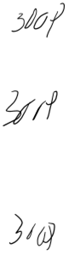cv\\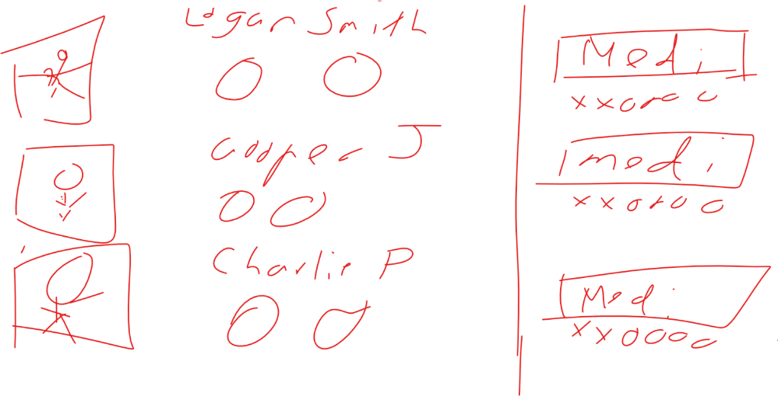

LOGIN SCREEN





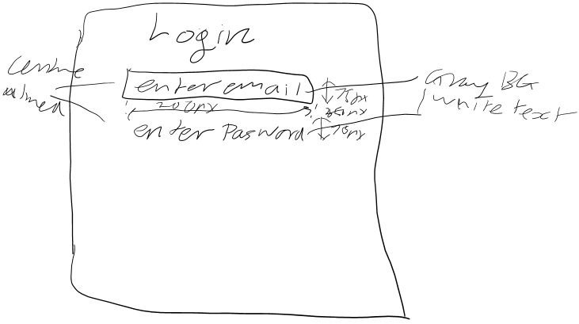



Possible Prototype visualisation


LOGIN pseudocode
BEGIN
isRunning ßtrue
WHILE isRunning
inputEmail ß INPUT
inputPasswordßINPUT
//teacher list is a list of teacher class with email, password, and other //information
FOREACH item in teacherList
IF inputEmail == teacherList.email THEN
IF inputPassword == teacherList.password THEN
isRunning ß False
END IF
END IF
END FOREACH
END WHILE
Login ß true
END

STUDENT SEARCH FUNCTION
BEGIN
isRunning ß true
WHILE isRunning
CuStudent ß INPUT
FOREACH item in studentList
If item == CuStudent.name THEN
PRINT CuStudent.cuLocation
ELSE
PRINT “Student not found”
END IF
END FOR
END WHILE
END

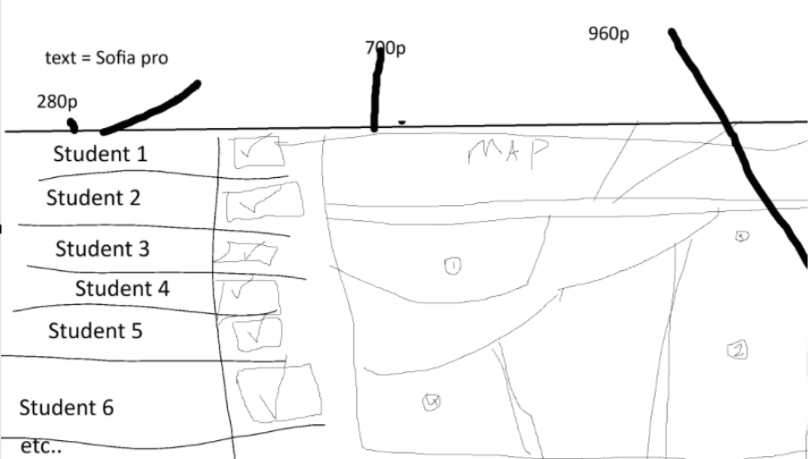z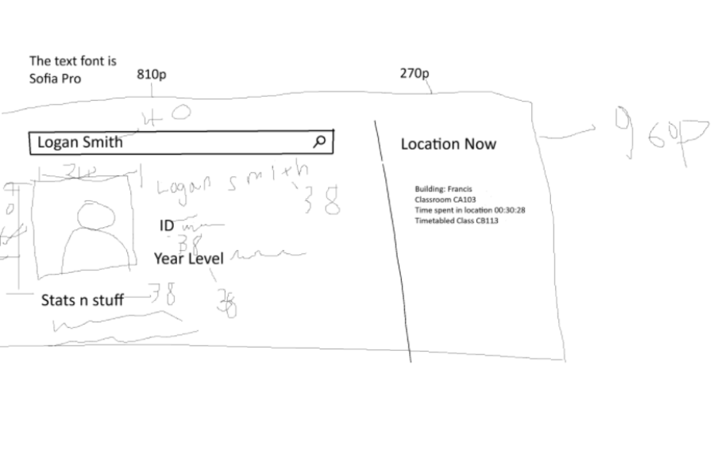
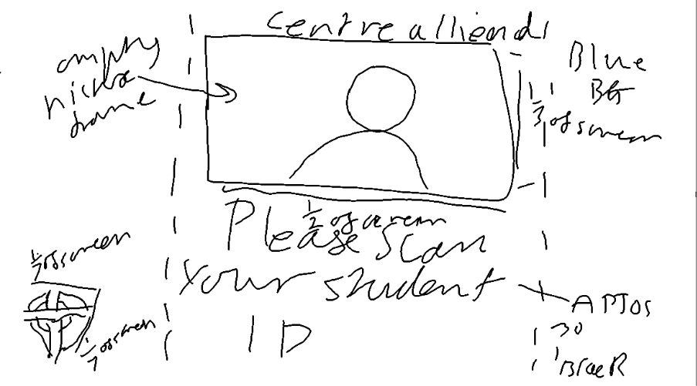
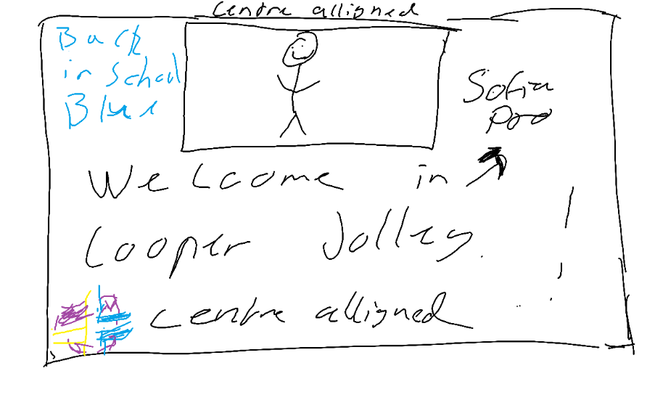
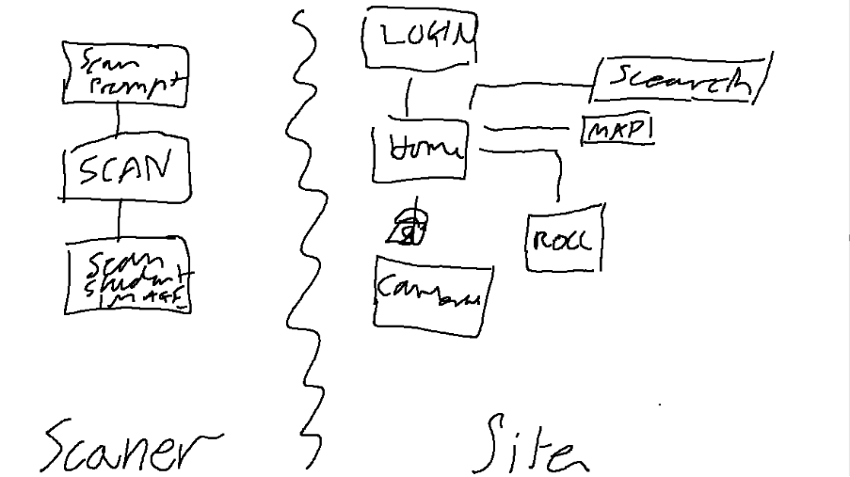

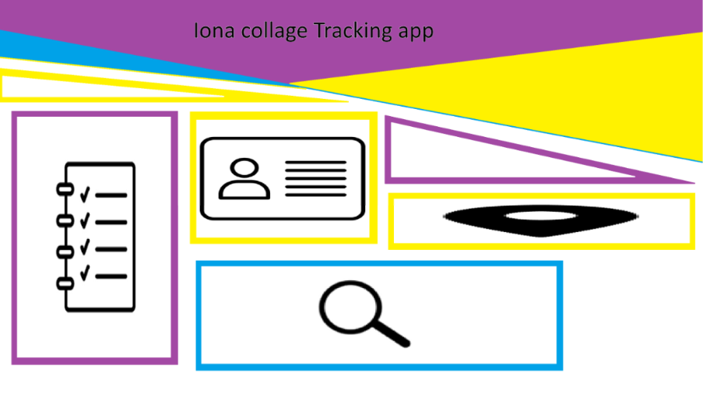
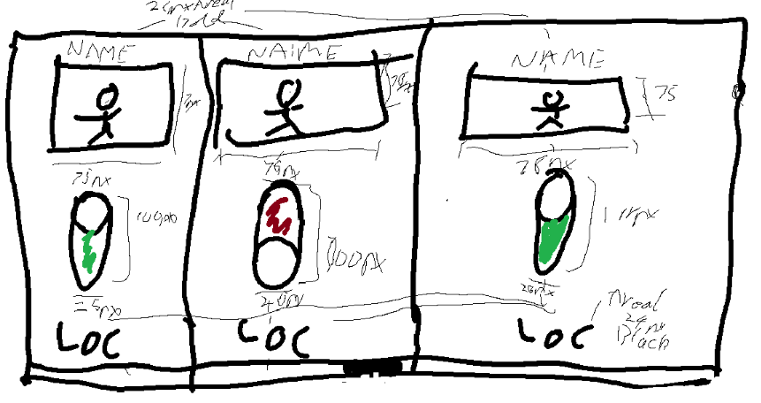
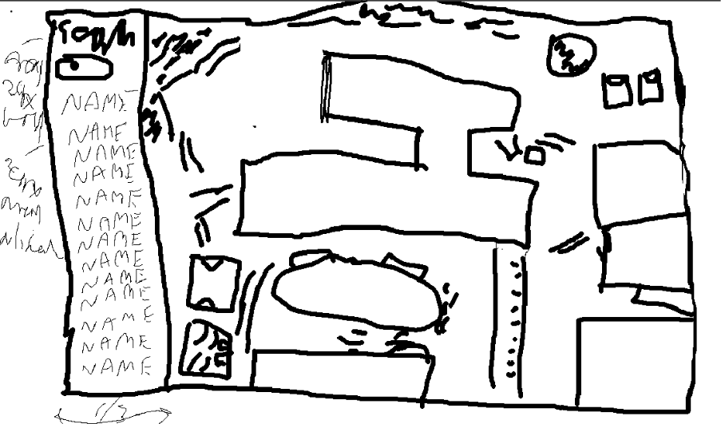

Judgement Criteria
 | Ease of use | Accessibility | Training required | Compatibility | Implement time | Ability to cope with constraints
NFC | 8/10 | I really | 5/10 | 8/10 | 9/10 | 8/10
Camera | 5/10 | Really I | 3/10 | 10/8 | 3/10 | 4/10

Test criteria, we are testing whether the log in would work then follow up with the frontend and backend solution( it failed twice) then we get information (failed once), the backend also failed.

